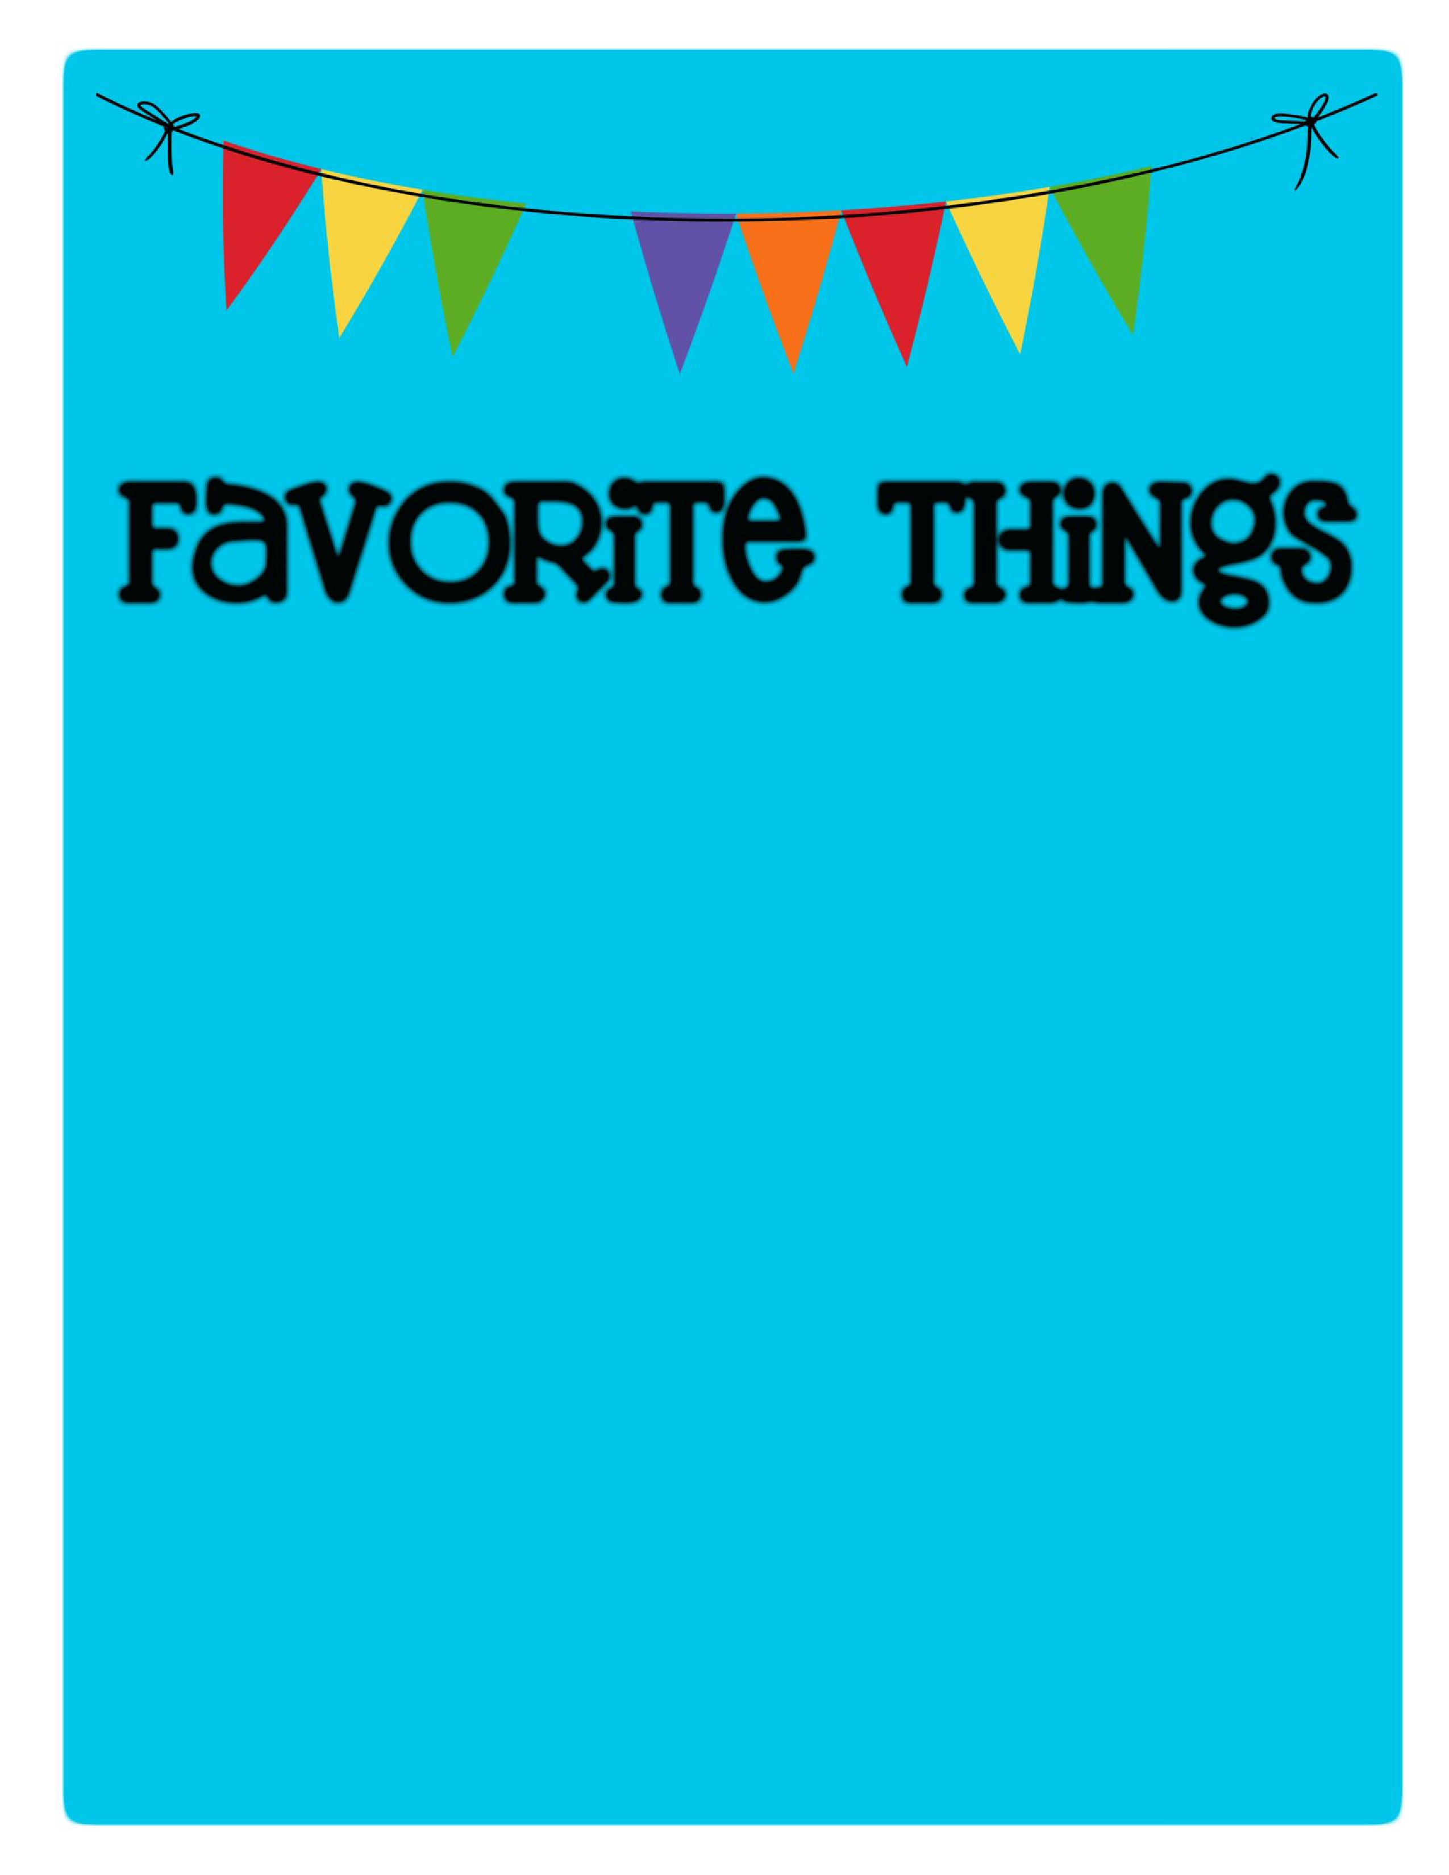

Name: Ms. Carolina _________________________

Birthday: _October 9th

Favorites

Places to Eat: ___In & Out, Salad & Go, Olive Garden _______________________________________________

Places to Shop:

_Bath & Body Works, Walmart, Target

Favorite Gift Cards:_ Black Rock & Starbucks

Drinks :

Starbucks

:

___Black Rock Hot Americano ________________________________

Sonic

:

__Cherry Slush____________________________________

Other

:

___Black Rock Hot Americano

Scents (lotion, Scentsy, etc.): Tropical Scent, Pumpkin, Cinnamon

Candy/Snacks: __Popcorn, Tree nuts & Peanuts _________________

Cookies/Cake: ______White Chocolate Macadamia Cookies

Flowers

:

____

All Flowers __________________________________________

Hobbies/Collectibles: ___Rhinos

Other Wish List Items: ­­­­­­­­­­­­­­­­­_________________________